Practical 8

Aim: Set up a new Django project named UniversityPortal. Create an application within it named Students using manage.py. Register the Students application and verify that you can access the Django admin interface.

Step 1: Create Project and App
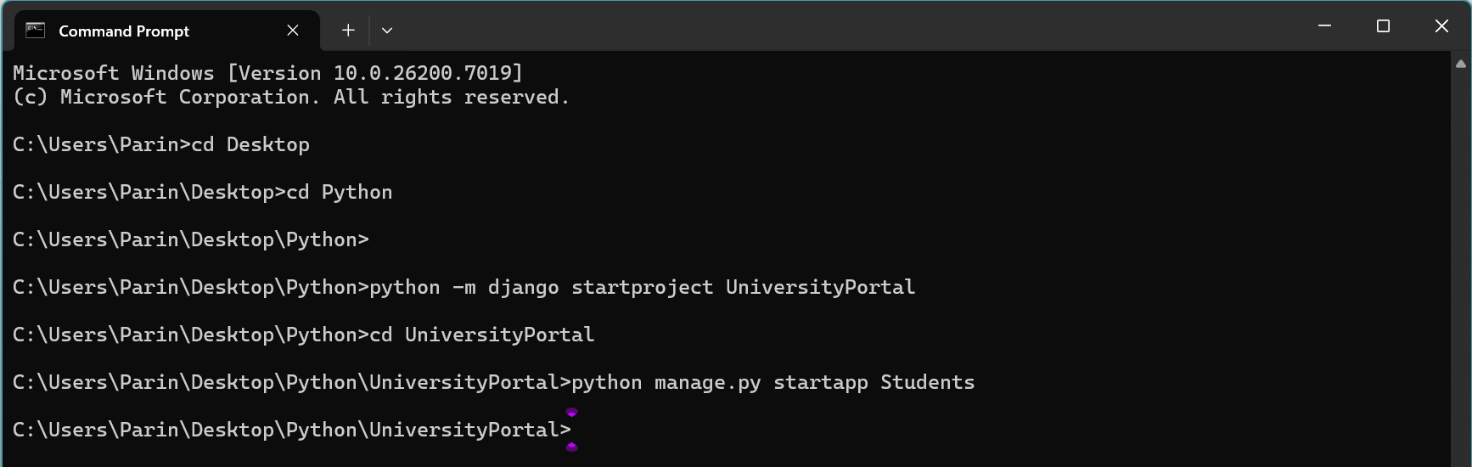
Step 2: Add App to Settings
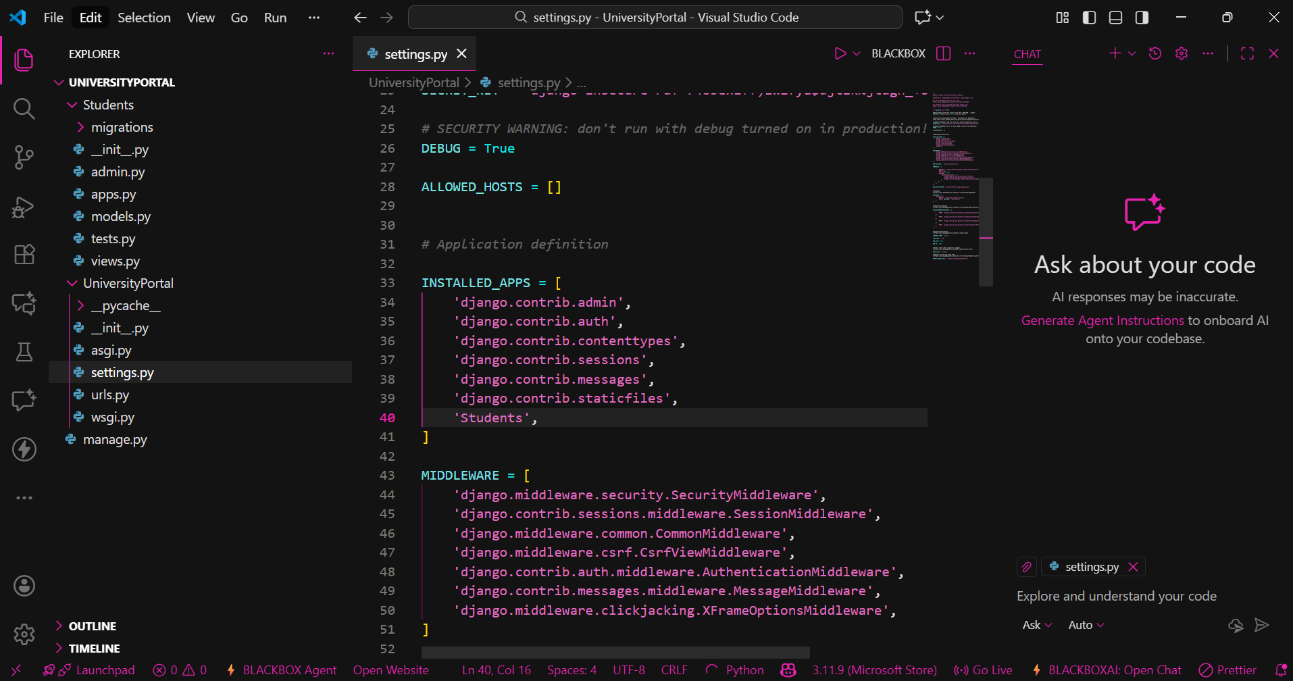
Step 3: Create Model
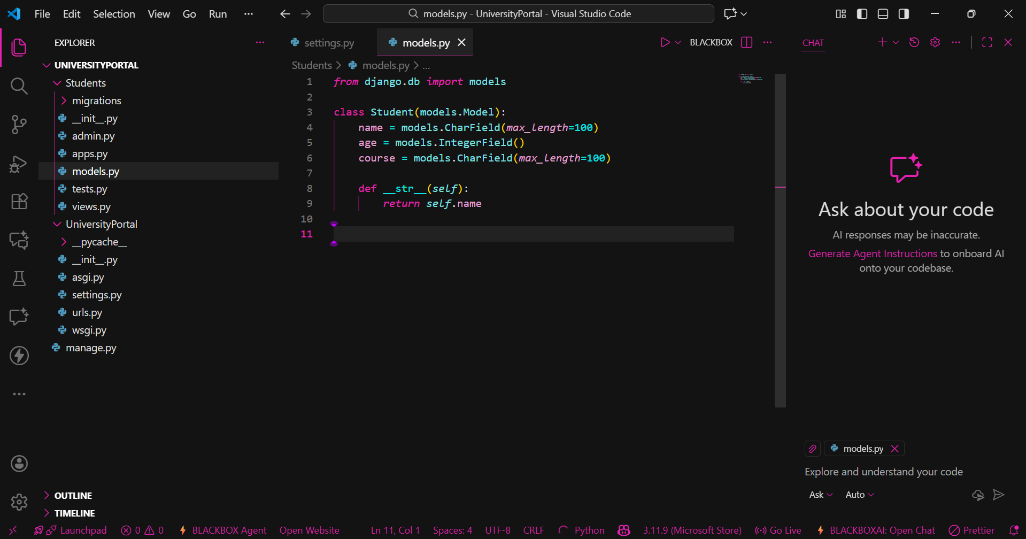
Step 4: Register Model in Admin
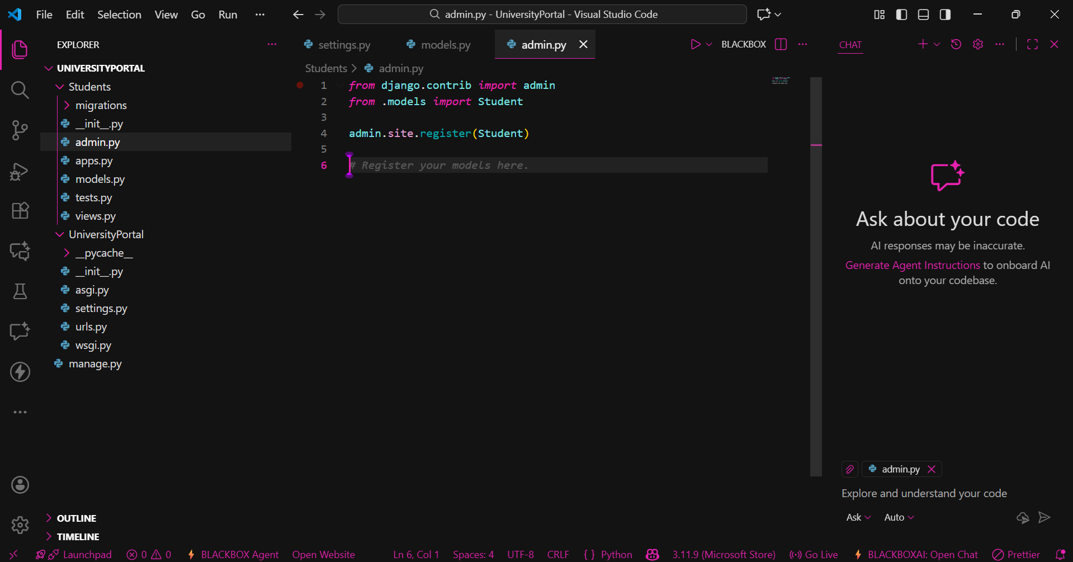
Step 5: Make migrations
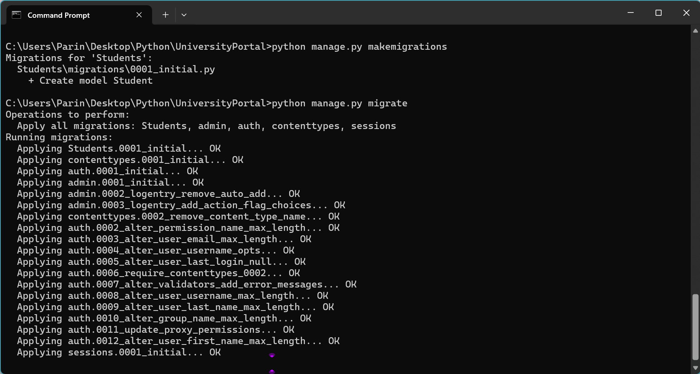

Step 6: Create Superuser
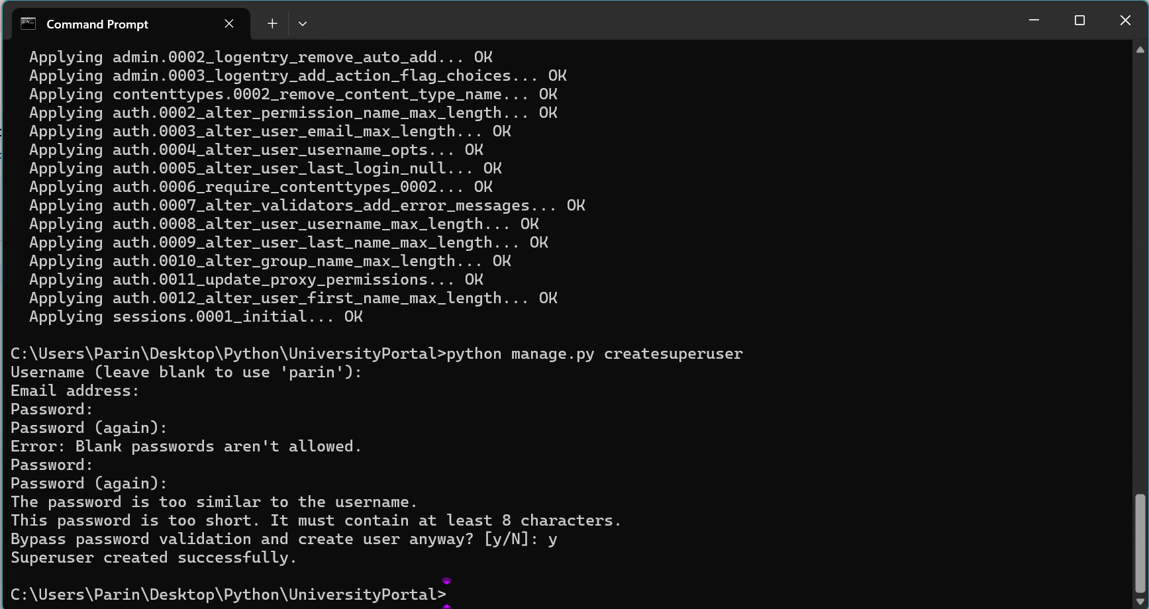

Output:

